**ONLINE SUPPLEMENT**

**TITLE**

Carriage and transmission of macrolide resistance genes in patients with chronic respiratory conditions and their close contacts

**AUTHOR’S FULL NAME**

Yiming Wang1,2, Steven L. Taylor1,2#,Jocelyn M. Choo1,2, Lito E. Papanicolas1,2, Rebecca Keating3, Kate Hindmarsh4, Rachel M. Thomson5, Lucy Morgan6, Geraint B. Rogers1,2†, Lucy D. Burr3,4†

**AUTHOR’S AFFILIATION**

1. Microbiome Research Laboratory, College of Medicine and Public Health, Flinders University, Adelaide, Australia

2. Microbiome & Host Health, South Australia Health and Medical Research Institute, North Terrace, Adelaide, Australia

3. Department of Respiratory Medicine, Mater Health Services, South Brisbane, QLD, Australia

4. Mater Research - University of Queensland, Aubigny Place, South Brisbane, QLD, Australia

5. Gallipoli Medical Research Institute, University of Queensland, Brisbane, QLD, Australia.

6. Department of Respiratory Medicine, Concord Repatriation General Hospital, NSW, Australia

**SUPPLEMENTARY METHODS**

***Inclusion and exclusion criteria for subject recruitment***

**Macrolide recipient (MR)**

* Inclusion criteria
  1. Age: 18 and above
  2. Must be able to provide written consent to participate
  3. Has at least one chronic lung disease including cystic fibrosis, asthma, or bronchiectasis
  4. Has been on azithromycin or erythromycin maintenance therapy for at least the preceding 6 months
* Exclusion criteria
  1. Unable to provide oropharyngeal swab sample for any reason
  2. Unable to accurately demonstrate / recall antibiotic exposure
  3. Prior non-macrolide antibiotic exposure (including clindamycin) in the prior 4 weeks

**Macrolide non-recipient (MNR)**

* Inclusion criteria
  1. Age: 18 and above
  2. Must be able to provide written consent to participate
  3. Has at least one chronic lung disease including cystic fibrosis, asthma, or bronchiectasis
  4. Is not currently on azithromycin/erythromycin maintenance therapy and has not received any macrolide antibiotics in the prior 6 months
* Exclusion criteria
  1. Unable to provide oropharyngeal swab sample for any reason
  2. Unable to accurately demonstrate / recall antibiotic exposure
  3. Prior non-macrolide antibiotic exposure (including clindamycin) in the prior 4 weeks

**Macrolide recipient close contacts (MRCC) and macrolide non-recipients close contacts (MNRCC)**

* Inclusion criteria
  1. Must be able to provide written consent to participate
  2. Is either a close household contact (Spouse, *de facto* or family members) who has lived with the patient for the immediate proceeding period at least 6 months or was a close family member (parent or sibling or partner) or friend who has had close contact with the patient over the immediate proceeding period of 2 years, as defined by at least 2 times a week.
  3. Have not received any antibiotics (any class) in the prior 4 weeks
  4. Has not received any macrolide in the prior 6 months
  5. No chronic respiratory disease, excepting well-controlled asthma
  6. Has not been treated as a patient in hospital in the past 4 weeks
* Exclusion criteria
  1. Unable to provide oropharyngeal swab sample for any reason
  2. Unable to accurately demonstrate / recall antibiotic exposure
  3. Prior non-macrolide antibiotic exposure (including clindamycin) in the prior 4 weeks

***Quantitation of total bacterial load, resistance gene carriage***

Quantitative PCR (qPCR) assays were employed to quantify the total bacterial load (16S qPCR), detect resistance genes, and quantify abundance of resistance genes in each sample. The SYBR Green method was employed for measuring CT values of six macrolide resistance genes [*erm*(A), *erm*(B), *erm*(C), *erm*(F), *msr*(A),and *msr*(E)] and three tetracycline resistance genes [*tetM*, *tetO*, and *tetW*]. A Taqman assay was used for assessing CT values of the macrolide resistance gene *mef.* Each reaction using the SYBR Green method was prepared with 17.5 µL 2×PowerUp SYBGreen Master Mix (Applied Biosystems, Foster City, CA, United States), 15.1 µL of Nuclease-Free water, 0.7 µL of 10 µM forward primer, 0.7 µl of 10 µM reverse primer, mixed with 1 µl of DNA template. Each reaction using the Taqman method was prepared with 17.5 µL 2×Kappa Fast probe low rox (KAPA Biosystems, Woburn, MA, United States), 14.05 µL of Nuclease-Free water, 0.875 µL of 10 µM forward primer, 0.875 µl of 10 µM reverse primer, 0.7 µL of µM probe, mixed with 1 µl of DNA template. The annealing temperature of 16S rRNA gene, *erm*(A), *erm*(B), *erm*(C), *erm*(F), *msr*(A), *msr*(*E*), *tetM* and *tetW* gene was 60 °C. The annealing temperature of *mef* and *tetO* gene was 62 °C.

Amplification efficiency and detection limits were determined for each resistance gene using serial dilutions of a positive control (DNA from a bacterial isolate confirmed to harbour the resistance gene) as previously described.

**e-Table 1.** Relationship between patient and close contact

|  |  |  |  |
| --- | --- | --- | --- |
| **Contact levels** | **Proportion** | **Relationship types** | **Proportion** |
| Household contact  (>6 months) | 86/93 | Family members  (Parent, siblings and children) | 28/86 |
| Partner, spouse or *de facto* | 58/86 |
| Friend | 0/86 |
| Regular contact  (>2 times per week in the last 2 years) | 7/93 | Family members  (Parent, siblings and children) | 3/7 |
| Partner, spouse or *de facto* | 1/7 |
| Friend | 3/7 |

**e-Table 2.** Quantitative PCR primers and probes

|  |  |  |  |  |
| --- | --- | --- | --- | --- |
| **Gene** | **Detection limit (Ct value)** | **Primer** | **Amplicon size (bp)** | **Reference** |
| **16S** | 27.50 | F: 5'-TCCTACGGGAGGCAGCAGT-3'  R: 5'-GGACTACCAGGGTATCTAATCCTGTT-3' | 467 | (E1) |
| ***erm*(A)** | 34.26 | F: 5'-TCAGTTACTGCTATAGAAATTGATGGAG-3'  R: 5'-ATACAGAGTCTACACTTGGCTTAGG-3' | 358 | (E2) |
| ***erm*(B)** | 34.64 | F: 5'-GAAAGCCRTGCGTCTGACATC-3'  R: 5'-CGAGACTTGAGTGTGCAAGAGC-3' | 105 | (E3) |
| ***erm*(C)** | 33.40 | F: 5'-CTTGTTGATCACGATAATTTCC-3'  R: 5'-ATCTTTTAGCAAACCCGTATTC-3' | 190 | (E4) |
| ***erm*(F)** | 32.59 | F: 5'-CGGGTCAGCACTTTACTATTG-3'  R: 5'-GGACCTACCTCATAGACAAG-3' | 466 | (E5, E6) |
| ***msr*(A)** | 34.04 | F: 5'-TCCAATCATTGCACAAAATCTAAC-3'  R: 5'-TCAATTCCCTCTATTTGGTGGT-3' | 165 | (E4) |
| ***msr*(E)** | 36.74 | F: 5'-TCGATACGAAGAGGCGATGC-3'  R: 5'-CTTCTGTTTGGTGCCGGTTG-3' | 163 | (E7) |
| ***tetM*** | 33.82 | F: 5'-CAGAATTAGGAAGCGTGGACAA-3'  R: 5'-CCTCTCTGACGTTCTAAAAGCGTAT-3' | 67 | (E8) |
| ***tetO*** | 31.96 | F: 5'-AACTTAGGCATTCTGGCTCAC-3'  R: 5'-TCCCACTGTTCCATATCGTCA-3' | 515 | (E3) |
| ***tetW*** | 31.31 | F: 5'-GAGAGCCTGCTATATGCCAGC-3'  R: 5'-GGGCGTATCCACAATGTTAAC-3' | 168 | (E9) |
| ***mef*** | 37.14 | F: 5'-TATGGAGCTACCTGTCTGGA-3'  R: 5'-GGTACTAAAAGTGGCGTAACC-3'  Probe: HEX-CCGTAGCATTGGAACAGCTTTTC-BHQ1 | 85 | (E10) |

F, forward primer; R, reverse primer; cycle number,40;

**e-Table 3.** Resistance gene detection frequency and relative abundance in close contacts of macrolide recipient and macrolide non-recipients.

|  |  |  |  |  |  |  |  |
| --- | --- | --- | --- | --- | --- | --- | --- |
| **Gene** | **Detection limit**  **(Ct value)** | **% of close contact**  **carried the gene** | | ***P* values** | **Normalised gene levels** | | ***P* values** |
| **MRCC** | **MNRCC** | **MRCC** | **MNRCC** |
| ***erm*(A)** | 34.26 | 0%  (0/53) | 0%  (0/40) | 0.99 | 0  (0.0-0.0) | 0  (0.0-0.0) | 0.50 |
| ***erm*(B)** | 34.64 | 85%  (45/53) | 85%  (34/40) | 0.99 | 3.4  (0.0-10.8) | 4.2  (0.0-10.1) | 0.48 |
| ***erm*(C)** | 33.40 | 7.5%  (4/53) | 5.0%  (2/40) | 0.70 | 0  (0.0-11.1) | 0  (0.0-9.9) | 0.42 |
| ***erm*(F)** | 32.59 | 45%  (24/53) | 65%  (26/40) | 0.09 | 0  (0.0-12.3) | 3.3  (0.0-9.9) | 0.065 |
| ***mef*** | 37.14 | 62%  (33/53) | 63%  (25/40) | 0.58 | 1.3  (0.0-5.6) | 1.2  (0.0-4.7) | 0.38 |
| ***msr*(A)** | 34.04 | 36%  (19/53) | 30%  (12/40) | 0.66 | 0  (0.0-12.7) | 0  (0.0-9.1) | 0.26 |
| ***msr*(E)** | 36.74 | 36%  (19/53) | 48%  (19/40) | 0.29 | 0  (0.0-13.5) | 0  (0.0-19.7) | 0.25 |
| ***tetM*** | 33.82 | 96%  (51/53) | 95%  (38/40) | 0.99 | 4.9  (2.3) | 4.4  (1.9) | 0.12 |
| ***tetO*** | 31.96 | 62%  (33/53) | 65%  (26/40) | 0.83 | 4.0  (0.0-10.0) | 4.9  (0.0-10.1) | 0.41 |
| ***tetW*** | 31.31 | 77%  (41/53) | 80%  (32/40) | 0.80 | 4.7  (0.0-11.3) | 5.0  (0.0-8.9) | 0.47 |

Abbreviations: MRCC: close contacts of patients who were receiving long-term macrolide therapy; MNRCC close contacts of patients who were not receiving any macrolide therapy. *P* value for detection frequency was determined by Fisher's exact test; *P* values for gene levels comparisons were determined by Mann-Whitney U test (non-parametric data, one-tailed test) and unpaired Student’s t test with Welch's correction (parametric data, one-tailed test). Close contact defined as either a close household contact (Spouse, defacto or family members) who has lived with the patient for the immediate proceeding period at least 6 months or is a close family member (parent or sibling or partner) or friend who has had close contact with the patient over the immediate proceeding period of 2 years, as defined by at least 2 times a week.

**REFERENCES**

E1. Nadkarni MA, Martin FE, Jacques NA, Hunter N. Determination of bacterial load by real-time PCR using a broad-range (universal) probe and primers set. *Microbiology* 2002; 148: 257-266.

E2. Jung JH, Yoon EJ, Choi EC, Choi SS. Development of TaqMan probe-based real-time PCR method for erm(A), erm(B), and erm(C), rapid detection of macrolide-lincosamide-streptogramin B resistance genes, from clinical isolates. *J Microbiol Biotechnol* 2009; 19: 1464-1469.

E3. Malhotra-Kumar S, Lammens C, Piessens J, Goossens H. Multiplex PCR for simultaneous detection of macrolide and tetracycline resistance determinants in streptococci. *Antimicrob Agents Chemother* 2005; 49: 4798-4800.

E4. Martineau F, Picard FJ, Lansac N, Menard C, Roy PH, Ouellette M, et al. Correlation between the resistance genotype determined by multiplex PCR assays and the antibiotic susceptibility patterns of Staphylococcus aureus and Staphylococcus epidermidis. *Antimicrob Agents Ch* 2000; 44: 231-238.

E5. Choo JM, Abell GCJ, Thomson R, Morgan L, Waterer G, Gordon DL, et al. Impact of Long-Term Erythromycin Therapy on the Oropharyngeal Microbiome and Resistance Gene Reservoir in Non-Cystic Fibrosis Bronchiectasis. *mSphere* 2018; 3.

E6. Chung WO, Werckenthin C, Schwarz S, Roberts MC. Host range of the ermF rRNA methylase gene in bacteria of human and animal origin. *J Antimicrob Chemother* 1999; 43: 5-14.

E7. Taylor SL, Leong LEX, Mobegi FM, Choo JM, Wesselingh S, Yang IA, et al. Long-Term Azithromycin Reduces Haemophilus influenzae and Increases Antibiotic Resistance in Severe Asthma. *Am J Respir Crit Care Med* 2019; 200: 309-317.

E8. Belen Florez A, Alegria A, Rossi F, Delgado S, Felis GE, Torriani S, et al. Molecular identification and quantification of tetracycline and erythromycin resistance genes in Spanish and Italian retail cheeses. *Biomed Res Int* 2014; 2014: 746859.

E9. Tao CW, Hsu BM, Ji WT, Hsu TK, Kao PM, Hsu CP, et al. Evaluation of five antibiotic resistance genes in wastewater treatment systems of swine farms by real-time PCR. *Sci Total Environ* 2014; 496: 116-121.

E10. Srinivasan V, du Plessis M, Beall BW, McGee L. Quadriplex real-time polymerase chain reaction (lytA, mef, erm, pbp2b(wt)) for pneumococcal detection and assessment of antibiotic susceptibility. *Diagn Microbiol Infect Dis* 2011; 71: 453-456.

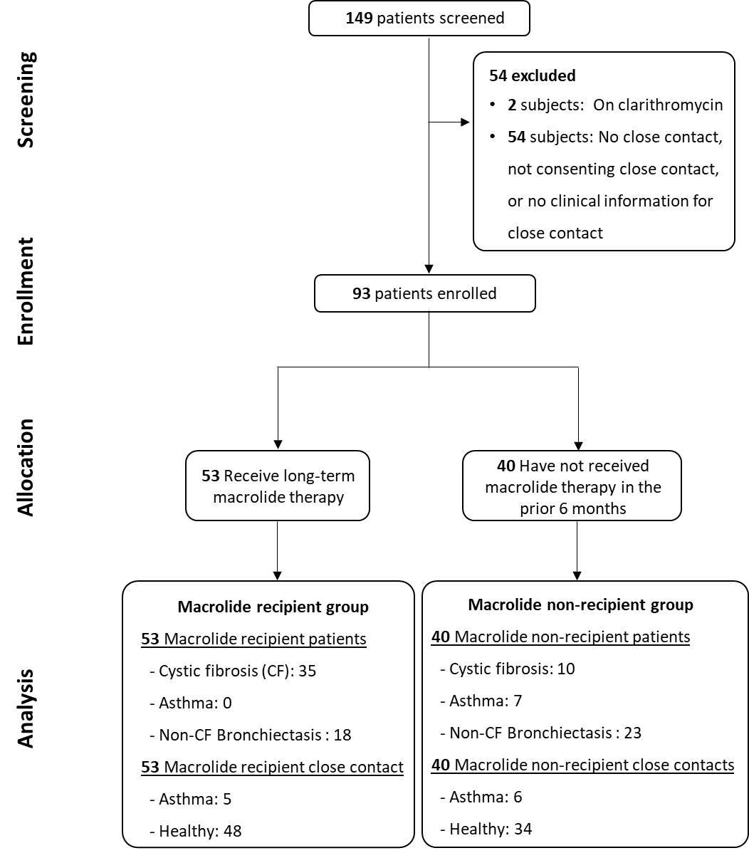

**e-Figure 1.** **Study design**

Subjects were recruited by respiratory physicians. Macrolide recipients: patients who receive macrolide maintenance therapy; Macrolide non-recipients: patients who have not received macrolide maintenance therapy in at least 6 months; Close contact defined as either a close household contact (Spouse, *de facto* or family members) who has lived with the patient for the immediate proceeding period at least 6 months or is a close family member (parent or sibling or partner) or friend who has had close contact with the patient over the immediate proceeding period of 2 years, as defined by at least 2 times a week. All patients were categorized based on their primary diagnosis.



**e-Figure 2.** **Resistance gene presence/absence map.**

Gene detection (red) determined by a qPCR amplification signal greater than the lowest positive serial dilution; P: patients; CC: paired close contact of patient; MR group: Macrolide recipient group; MNR group: Macrolide non-recipient group